**Initial explanation of the EMMPOWER Mosquito data for Daniel Smith – January 2020**

**Mini-project 2: Spatial multivariate analysis of extant mosquito community dataset in relation to landscape, management and biotic factors**

**Relevant papers**

What is the relative role of landscape changes, climate and host factors in driving

mosquito abundance and seasonality?

<https://besjournals.onlinelibrary.wiley.com/doi/full/10.1111/1365-2656.12805>

<https://www.nature.com/articles/srep29002> LOOK AT THE REFS THAT HAVE CITED THIS ONE

Steiger, D. M. et al. Effects of landscape disturbance on mosquito community composition in tropical Australia. J. Vector Ecol. 37, 69–76 (2012).

Li, Y. et al. Urbanization increases Aedes albopictus larval habitats and accelerates mosquito development and survivorship. PLoS Negl. Trop. Dis. 8, e3301 (2014).

Townroe, S. and Callaghan, A. (2014) British container breeding mosquitoes: the impact of urbanisation and climate change on community composition and phenology. PLoS ONE, 9 (4). 5325. ISSN 1932-6203 doi: <https://doi.org/10.1371/journal.pone.0095325>

**Background documents**

**EDEN_poster_May2010.pdf from Steffi gives a nice overview**

**Report on preliminary EMMPOWER analysis_CommentsSteffi.docx** gives you an idea of the spatial and seasonal data collection, species present and their abundances, predictors available, predictors remaining to be collected from GIS.

**How the sample sites were arranged and stratified**

P:\NEC03667_EMMPOWER\SLMs GIS Data

There were 18 larval sampling sites across the coastal grazing marsh of the Somerset Levels.

Each “site” was actually 4 sub-sites within a 500m plot, containing a section of rhyne, divided into 6 dip points. The figure below shows examples of 2 of the 500m sites. The whole of a “site” was usually one Tier level of management.

Sites were stratified by tiers of management, that differ in stocking density, fertiliser and pesticide use, water levels maintained. The differences between the tiers is summarised here and the over-arching initial hypothesis was that the Tier 3 management, with raised water levels, would provide more extensive larval habitat for survival of mosquitoes through the winter.

**selection of SLM zones for mosquito trapping.docx** and **ESA raised water level Tier rules.docx** gives you some brief description of the tier levels

P:\NEC03667_EMMPOWER\Tier_Levels_info

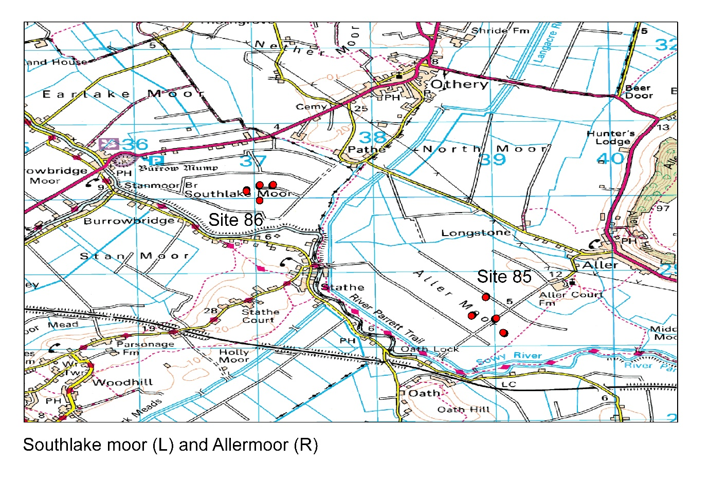

Fig. 1.

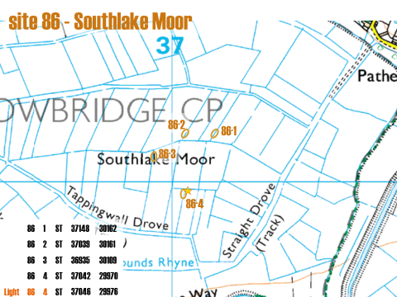

Fig. 2. Show an example of how the 4 rhynes were situated for the South Lake Moor site

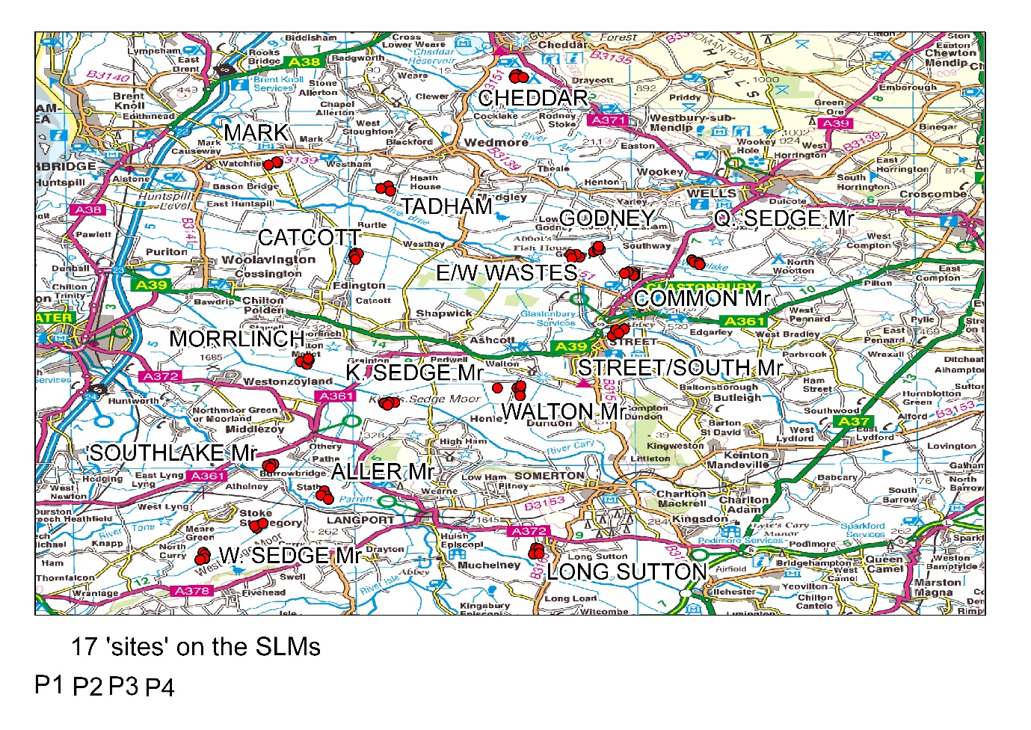

P:\NEC03667_EMMPOWER\Analysis_Beth_Edinburgh_March_2011

**Mosquito and ground-measured environmental data**

P:\NEC03667_EMMPOWER\Analysis_data_SLM_2009-2011

The mosquito data are in:

P:\NEC03667_EMMPOWER\Analysis_data_SLM_2009-2011\2009_2010_2011_Larvae_Dipping_totals_vr20_INTERLINKABLE.xlsx

The “environmental” data are in:

P:\NEC03667_EMMPOWER\Analysis_data_SLM_2009-2011\2009_2010_2011_SLM_metadata_veg_predators_physicochemicals_vr8_INTERLINKABLE.xlsx

These each have 2415 rows and are described by Steffi as inter-linkable. It would be worth making a unique identifier for each row composed of say the Site, plot, year and season and then checking the order matches between the files.

Some of the measures were made per dip point and some were made for the whole rhyne. I would be tempted to analyse the data at rhyne level, rather than per dip point.

It is also important to notice that the chemistry and temperature data would be very variable within a day at that the rhynes were visited at different times of day and under different weather conditions. So we need to think carefully about how, and at what level to use these data.

Vegetation data: there is a huge wealth of species for which % cover was recorded at the centre and edge of the rhyne. I would suggest you start from the 5 mosquitoes known habitat traits and come up with a few vegetation metrics that you think are important, rather than conducting a full multivariate analysis of the species vegetation data. See Nick Golding’s papers for the example vegetation metrics he pulled out from similar kind of data for North Kent. Note also that the vegetation was not routinely well recorded in the first season or so of sampling. Steffi has an identifying column that indicates this.

Available **GIS data** I have are here W:\dir_beth\EMPOWER

W:\dir_beth\EMPOWER\Nat_England

These folders contain shapefiles of all the **wetland types** in the Somerset area and looking at composition of these around sites would be useful (though in practice we will analyse probably only the coastal grazing marsh sites that are either Tier 1 or Tier 3, see water_tier_management column V in the sheets).

W:\dir_beth\EMPOWER\SLM OS Data contains the **OS data** for these tiles

W:\dir_beth\EMPOWER\LCM2000 25m Raster Beth Purse

purban171_172 – I think was classes of **urban and suburban fabric from the CEH Landcover Map 2000** but this would be worth redoing with land cover map 2007.

This shapefile in the overall folder is the **boundaries from the overall area** boundaries_na_85_Somerset_Levels_and_moors.shp

W:\dir_beth\EMPOWER\tadham\dataFromDefra\arcview

The **tiers and attributes of field across the levels** are in SLLCFIN.shp

All the data layers are extracted to some of the sites in the files May2009_sitese & suggested_sites_May09d.xlsx

We might want to think about DTM data, soil moisture, road proximity etc but the main thing will be to think carefully about a small number of metrics that we know aprior mosquitoes are sensitive to.